**Registration No: Sp24 – bse - 096**

**User Registration Form Using JavaFX**

This program creates a simple user registration form using JavaFX. It allows users to input their details, including their name, ID, gender, province, and date of birth, and saves this data into a text file. Below is an explanation of the main components of the program, along with the associated code.

**Main Components of the Program**

**1. Save Data to File**

The program saves the user’s information (entered in the form) into a file named user_data_v2.txt. The data is saved in a structured format, and a confirmation alert is shown upon successful saving. If the process fails, an error alert is displayed.

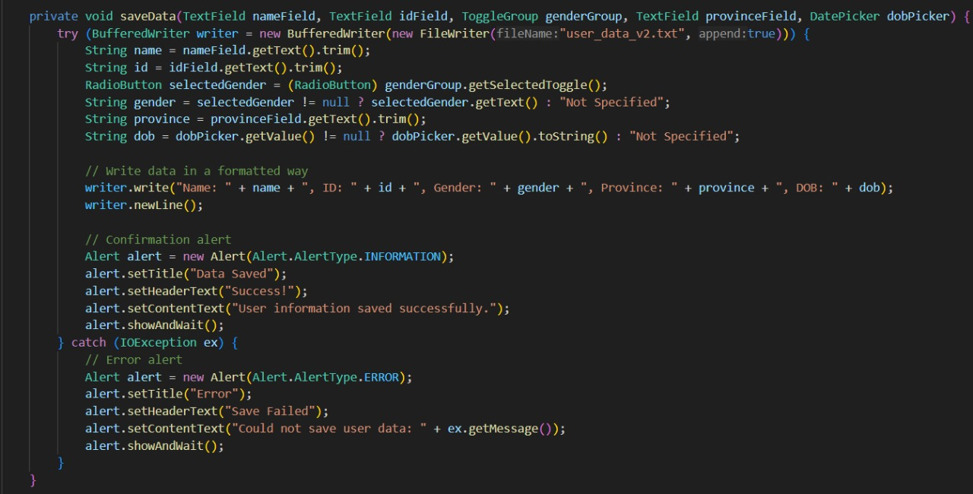

**2. User Interface Design**

The user interface uses **JavaFX layouts** to organize elements. It includes labels, input fields, buttons, and a date picker. A GridPane layout is used to arrange the form fields neatly, while a VBox layout contains the form and buttons.

**3. Button Functionality**

The form includes buttons for submitting data, exiting the application, and placeholders for other functionalities. The "Submit" button saves the user’s data to the file, and the "Exit" button closes the application.

* **Save Button**: Saves the form data to the text file and shows a success alert.
* **Exit Button**: Closes the application window.

**4. Alerts for Feedback**

* The program uses **JavaFX Alerts** to provide feedback to the user. For example, a success message is shown after data is saved successfully, or an error message is displayed if file saving fails.

**How the Program Works**

1. **Launch the Application**:  
   The program starts by displaying a user registration form.
2. **Input Data**:  
   The user enters their details (e.g., name, ID, gender, province, date of birth).
3. **Submit Data**:  
   On clicking the "Submit" button, the program saves the data into a text file and provides feedback via a success alert.
4. **Exit the Application**:  
   The "Exit" button closes the application window.

**THE FINAL OUTPUT**

